THIRD TERM
SUBJECT DATA PROCESSING CLASS: S. S. S TWO DURATION 2 HRS
Answer the following questions

- ______ is used to store and modify a database (a) Adobe (b) DBMS (c) MS DOS (d) DOC
- ______ are examples of presentation package except (a) OpenOffice impress (b) Iproject Pro (c) Ms PowerPoint (d) none
- Thwe power point environment consist of the following except (a) title bar (b) menu bar (c) slide pane (d) file pane
- A presentation package allows one to _______ contents of one's documents (a) review and rebroadcast (b) prepare and present (c) program (d) format
- The HTML represent Hyper Text _____ ______ (a) makeup list (b) markup link (c) markup language (d) mixedup list
- One can not insert _________ into a presentation content (a) javaScript (b) audio (c) charts (d) video
- All are examples of database packages except ____ (a) DB word (b) SQL server (c) DBase (d) MS Access
- ______ is not an application of database (a) Automated Teller Machine (b) computerized library system (c) flight reservation system (d) pc maintenance
- To have our presentation on a larger view, contents could be presented using the ______(a) Lcd monitor (b) Lcd projector (c) web (d) none
- The Ms PowerPoint essentially contains the following features except (a) menu bar (b) status bar (c) content bar (d) title bar
- The Home tab contains the slides ,fonts , _______ (a) alignments (b) help (c) navigations (d) ruler
- A WYSIWYG web design package brings easier ______ in web designing (a) editing (b) coding (c) programming (d) hosting
- In web design, the _______ language type is used (a) java (b) basic (c) markup (d) makeup
- _________ is an example of web design package (a) PDF reader (b) Dream weaver (c) Ms word (d) Corel draw
- The following are components of a good web site except (a) good colors scheme (b) layout (c) good typography (d) heavy graphics
- All are websites except (a) www.google.com (b) www.facebook.com (c) eliasschools@yahoo.com (d) www.wikipedia.com
- Ctrl + M is used on the power point to insert _______ (a) new document (b) new pane (c) new slide (d) new template
- A ______ package produces vector images (a) vector (b) drawing (c) painting (d) CAD
- All are types of keys except _____ (a) candidate key (b) student key (c) super key (d) primary key
- A table is also known as ______ in database (a) chart (b) relation (c) cells (d) graphs
- All are uses of the graphic package except ______ (a) for creating posters and billboard design (b) database management (c) animations (d) movie special effects
- A _______ package produces images by changing the colour of pixels on the screen (a) drawing (b) painting (c) designing (d) colour
- All are advantages of the drawing package except _______ (a) individual obect can be edited (b) the use less memory (c) they look unrealistic (d) none
- CAD means ___________ (a) computer auto desgin (b) computer aided device(c) computer animation design (d) card auto design
- All are examples of graphic packages except ______ (a) word express (b) adobe photoshop (c) coreldraw (d) widows paint
- Which is not a feature common to graphic package (a) select tool (b) magnifier (c) colour palette (d) blade
- To initiate the Save command , the ______ is used (a) Crtl + S (b) Crtl – S (c) shift + S (d) Alt + S
- What makes the Save and Save As command different is that,Save is used for _____ (a) saving already saved file (b) saving with option of renaming (c) all of the above (d) none
- Ctrl + E aligns the text to the _______ (a) end (b) right (c) left (d) centre
- Which of the following is not a font attribute (a) Bold (b) underline (c) italic (d) margin
- Bitmapped graphics are used for (a) photographs (b) shapes (c) vector objects (d) none
- _____ can be used to close down application on the Windows except (a) Ctrl + X (b) Alt + f4 (c) click exit from file menu (d) click the cancel (X) button at title bar
- _________ are coded as a pattern of bits to create a bitmapped graphics file (a) bytes (b) variables (c) pixels (d) graphics
- To ensure the battery in your laptop has a long and healthy life, avoid _____(a) charging (b) over charging (c) using it (d) nothing
- To clean or blow the dirts on a keyboard,the dash should be used (a) compressed water (b) compressed alchohol (c) can with compressed air (d) wet sponge
- All these drains the battery faster except ________ (a) harddisk access (b) DVD rom access (c) screen brightness (d) booting
- _____ is not a datatype in MS ACCESS (a) memo (b) text (c) numbers (d) mnemonics
- The ……….. model describes how the database will be built. (a) conceptual (b) logical (c) physical (d) soft
- The ____ bar displays the document name and name of program (a) menu bar (b) title bar (c) status bar (d) help bar
- ____ resembles a fill-in-the-blank sheet that will be filled manually (a) report (b) Queries (c) cell (d) form
Theory Section
Answer only three questions in this section
1. (i) Define application package
(ii) State one use each of any four application packages
List two benefits of a presentation package.
Outline three guidelines for creating a good MS PowerPoint presentation.
2. a. Define the terms I. Web design II. Web design package
B. Mention any 3 examples of the web design packages
3. A. What are graphic packages ?
B. Mention types of graphics packages
C. State 4 uses of the graphics package
4. A general hospital decides to computerize the records in all its departments.
a. State one database management system that can be used for this project
b. List two ways of preventing unauthorized access to the stored data
c. Define the term Database

Test of Practical (Compulsory)
Test of Practical (Compulsory)
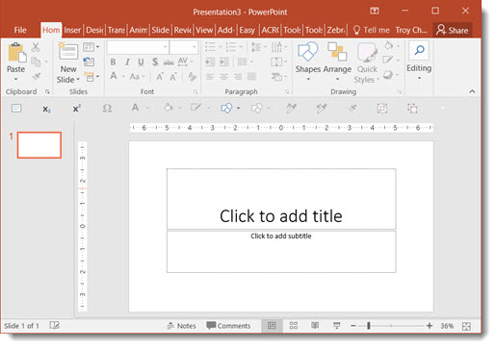
- What is the name of the above software package?
- What is the purpose of the application
- Name 3 application of the software package
- State in steps how to insert a picture into a blank slide
- State the keyboard shortcuts for the following
a. To create a new slide
b. To save
c. To open or retrieve a document

